**DAILY ONLINE ACTIVITIES SUMMARY**

|  |  |  |  |  |  |  |  |  |
| --- | --- | --- | --- | --- | --- | --- | --- | --- |
| **Date:** | **23-05-2020** | | | | | **Name:** | **Pavana P** | |
| **Sem & Sec** | **6A** | | | | | **USN:** | **4AL17CS057** | |
| **Online Test Summary** | | | | | | | | |
| **Subject** | | **PAP** | | | | | | |
| **Max. Marks** | | **30** | | **Score** | | | **18** | |
| **Certification Course Summary** | | | | | | | | |
| **Course** | **DATA SCIENCE WITH OPEN DATA** | | | | | | | |
| **Certificate Provider** | | | Cognitive classes | | **Duration** | | | 4 hours |
| **Coding Challenges** | | | | | | | | |
| **Problem Statement:**  1.Write a C Program to Generate First N Triangular Numbers (Where N is read from the Keyboard) | | | | | | | | |
| **Status: Completed** | | | | | | | | |
| **Uploaded the report in Github** | | | | | **YES** | | | |
| **If yes Repository name** | | | | | **DAILY STATUS** | | | |
| **Uploaded the report in slack** | | | | | **YES** | | | |

.

**Online Test :**

Subject:-PAP 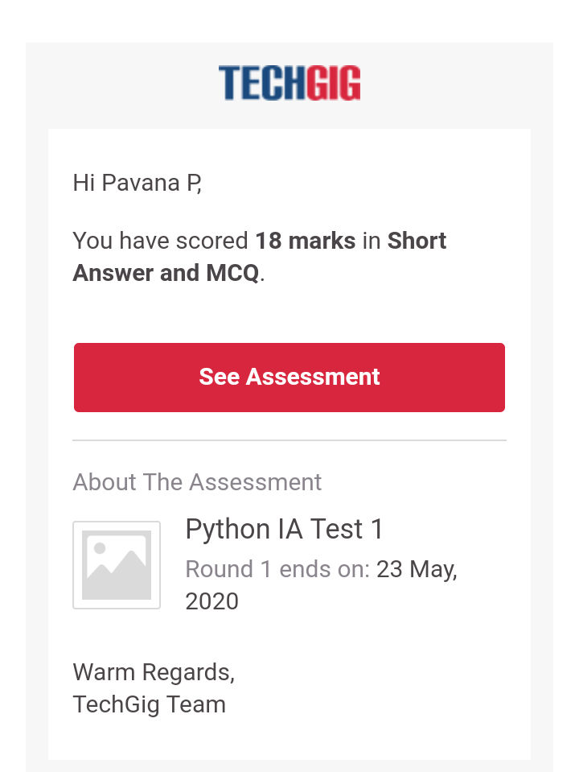

**Certification Course Details:**

**Data Science with Open Data :**

Today I have completed these topics:

1.What is NEB.

2.NEB Data sets.

3.Charts with NEB open data.

4.Rstudio cloud.

.

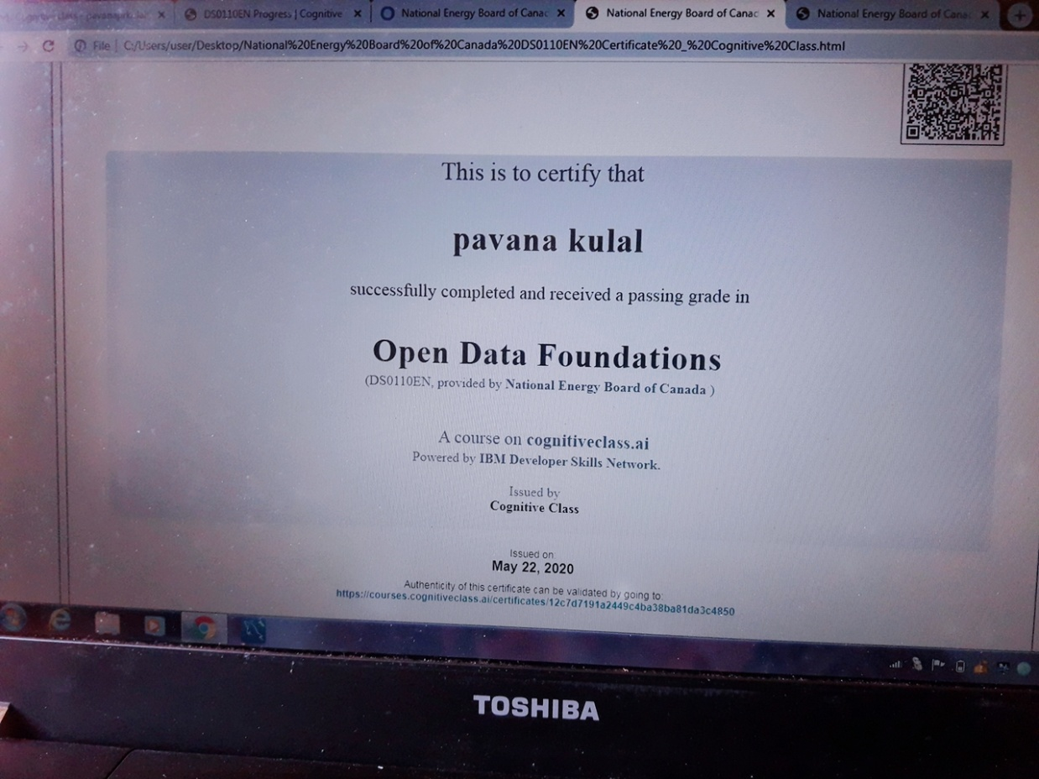

**Coding Challenges Details:**

**https://github.com/pavana-p-kulal/DAILY-STATUS/tree/master/23-5-20/Online%20Coding**